**PLOT A**

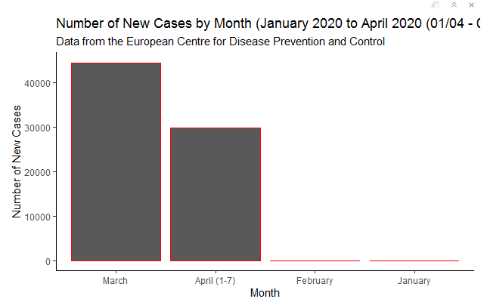

*title = April 2020 (01/04 – 07/04)